import matplotlib.pyplot as plt

delivery_times = [
32, 28, 45, 30, 36, 40, 29, 34, 38, 31,
27, 41, 33, 35, 39, 37, 44, 30, 29, 32,
36, 28, 43, 31, 35, 40, 38, 33, 30, 42
]

plt.hist(delivery_times)

plt.xlabel("Delivery Time (minutes)")
plt.ylabel("Frequency")
plt.title("Swiggy Delivery Time Distribution")

plt.show()
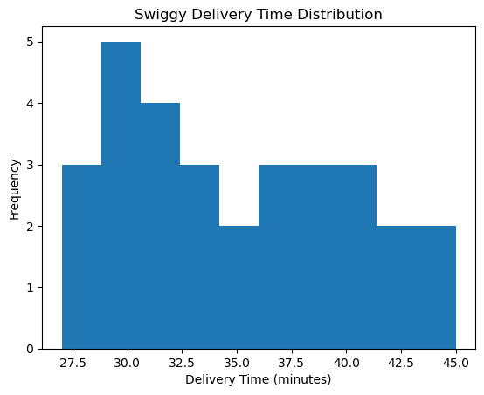
import matplotlib.pyplot as plt

scores = [
125, 140, 155, 170, 180, 195, 210, 145, 160, 175,
185, 200, 215, 130, 150, 165, 190, 205, 220, 135,
148, 158, 172, 182, 198, 208, 218, 128, 142, 162,
177, 188, 202, 212, 134, 152, 168, 179, 193, 207,
217, 126, 146, 156, 174, 186, 196, 204, 214, 132
]

# 5 bins
plt.hist(scores, bins=5)
plt.title("IPL Scores - 5 Bins")
plt.xlabel("Runs")
plt.ylabel("Frequency")
plt.show()

# 10 bins
plt.hist(scores, bins=10)
plt.title("IPL Scores - 10 Bins")
plt.xlabel("Runs")
plt.ylabel("Frequency")
plt.show()

# 15 bins
plt.hist(scores, bins=15)
plt.title("IPL Scores - 15 Bins")
plt.xlabel("Runs")
plt.ylabel("Frequency")
plt.show()
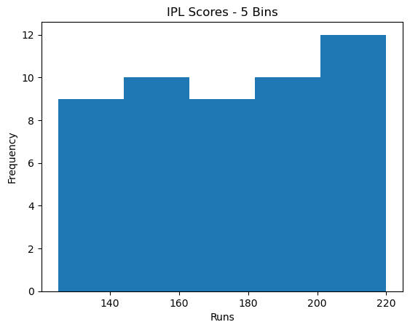
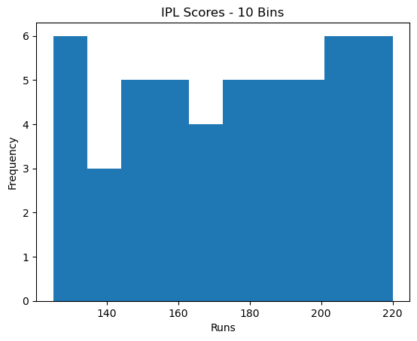
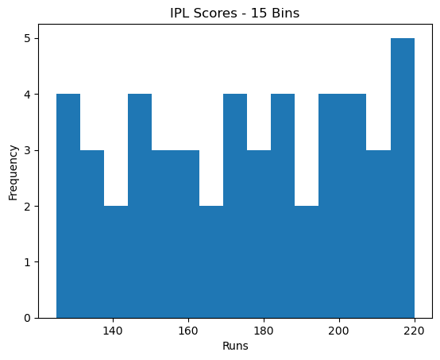
import matplotlib.pyplot as plt

steps = [
4500, 5200, 6000, 7000, 5500, 8000, 7500,
6200, 6800, 7200, 5000, 5800, 9000, 8500,
7600, 6400, 7100, 6900, 5300, 6100,
4700, 5600, 7300, 8200, 8800, 6600, 5900,
7000, 7800, 8400
]

# Frequency histogram
plt.hist(steps, bins=5)

plt.xlabel("Daily Steps")
plt.ylabel("Frequency")
plt.title("Daily Steps - Frequency")

plt.show()

# Density histogram
plt.hist(steps, bins=5, density=True)

plt.xlabel("Daily Steps")
plt.ylabel("Density")
plt.title("Daily Steps - Density")

plt.show()
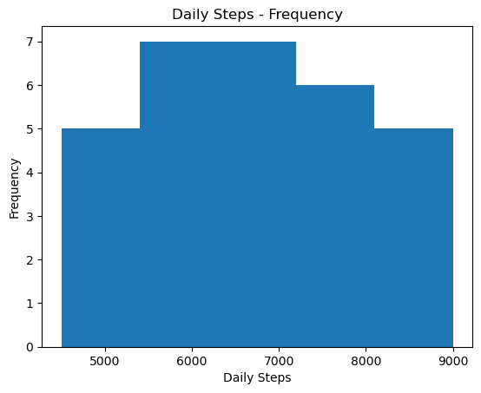
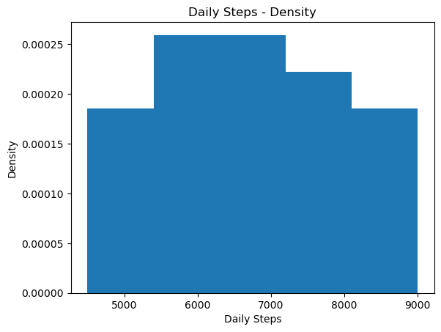
import matplotlib.pyplot as plt
import numpy as np

durations = np.random.randint(120, 301, 50)

plt.hist(
durations,
color='purple'
)

plt.xlabel("Song Duration (seconds)")
plt.ylabel("Frequency")
plt.title("Spotify Song Duration Distribution")

plt.show()
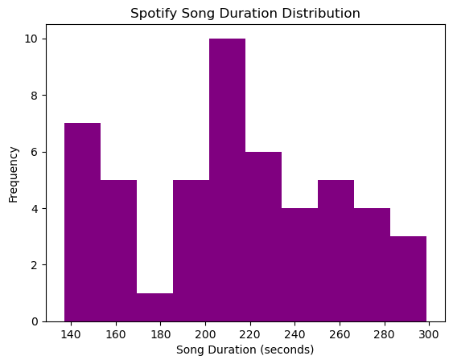
import matplotlib.pyplot as plt

prices = [
150, 250, 450, 500,
600, 750, 950, 1000,
1200, 1500, 1800, 2000,
2200, 3000, 4000, 4800
]

bins = [100, 501, 1001, 2001, 5001]

plt.hist(prices, bins=bins)

plt.xlabel("Product Price")
plt.ylabel("Frequency")
plt.title("Flipkart Product Price Distribution")

plt.show()
